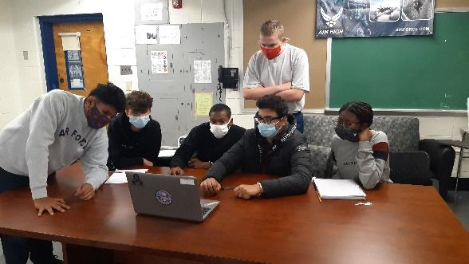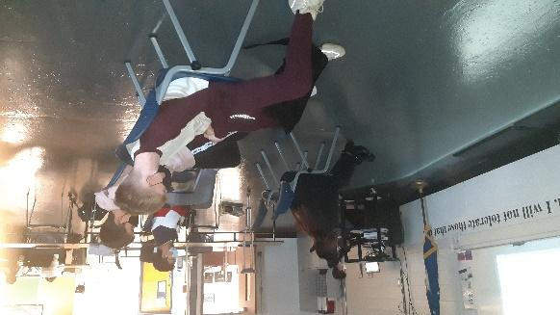

Cadets from Highland High School’s Air Force Junior Reserve Officer Training Corps (AFJROTC) competed in College Options Foundation’s annual Leadership and Academic Bowl (JLAB) competition. There are many benefits of participating in the Academic Bowl: Improve SAT/ACT scores, access to college prep materials, increase interest in college admissions, demonstrate academic strength of the JROTC program, boost esprit de corps, and earn the opportunity to travel to our nation’s capital if selected for the final competition.
One of the main goals of the JROTC Academic Bowl is to prepare students for state exit/graduation exams as well as college entrance exams, such as the SAT and ACT. Questions cover language arts, math, and science in each level of the competition. The JROTC curriculum questions in Level I focus primarily on leadership preparation, wellness and fitness, group/team dynamics, and communication skills. A few questions about current events are also included –
Highland High School AFJROTC fielded two teams totaling 11 cadets. Matheiu Carhuaz, Drew Wonderlin, Aziz Muhammad-Kane, Jason Swart, Muhammad Alam, and Alani Franklin competed in the morning then Gavin Gallo, Maryam Yasir, Santiago Colonia, Benjamin Burdock, and Aidan Anderson competed in the early afternoon. They will continue to train in preparation for Round Two in January under the supervision and direction of team captains Muhammad Alam and Gavin Gallo.
If you have any questions on JLAB or Air Force JROTC please contact Major Simpson rsimpson@bhprsd.org or Chief Mahoney rmahoney@bhprsd.org.

